REPORT ON INTERNSHIP

Internship at SELISE

REPORT ON INTERNSHIP

Course Code: SE 701





**Submitted to**

Intern Placement Office

Institute of Information Technology

University of Dhaka

**Submitted by**

Pritom Kumar Das

BSSE 0919

Institute of Information Technology

University of Dhaka

**Submission Date :**

LETTER OF TRANSMITTAL

June 25, 2020

The Chairman

Intern Placement Office

Institute of Information Technology

University of Dhaka

Dear Sir,

It’s a great pleasure to me to submit my internship report as a part of internship program. Giving the opportunity to relate my academic knowledge with recent software trends in renowned software industry and make the opportunity to gather great experience from industry, I am so thankful to Institute of Information Technology. This report is based on my learning and experience during my internship time period, starting from January 01, 2020 to June 30, 2020.

This report both covers the technical skills that I gained through my internship program and represents my project involvements, professional growth and other improvements and issues. It is believed that the report will exhibit the overall outcomes of my internship course. I am looking forward to your effective feedbacks on my entire report.

Sincerely yours,

Pritom Kumar Das

BSSE 0919

7th Semester

Bachelor of Science in Software Engineering

Institute of Information Technology

University of Dhaka.

LETTER OF ENDORSEMENT

To Whom It May Concern

**Subject:** Approval of the Report

This letter is to certify that, all the information mentioned in this document is true and not confidential to the company. The projects mentioned here have had successful involvement of Mr. Pritom Kumar Das, (BSSE0919), Institute of Information Technology, and University of Dhaka.

I wish him all the best and hope that he will lead a successful career.

------------------------------------

Istiaq Ahmed

Software Architect

Secure Link Service Ltd

ACKNOWLEDGEMENT

Firstly, I am really thankful to Institute of Information technology and it’s Intern Program Office for arranging the wonderful internship program for me. I am also grateful to SELISE for recruiting me as an intern.

I take this chance to express my significant appreciation and profound respects to Shumon Sarker, Head of Department (SELISE SME Solutions) for his praiseworthy direction, observing and steady consolation during my entire internship.

I also would like to thank Dr. Md. Shariful Islam, Professor and Director of Institute of Information Technology, University of Dhaka for giving me the opportunity to take part in the internship such a renowned organization.

I also make this chance to express a profound sense for gratitude to Istiaq Ahmed, Software Architect of SELISE and my supervisor for his friendly support, guidance.

I am likewise grateful to all my team members and individuals from SELISE for making my adventure smooth and noteworthy. Finally I would thank and tremendous gratitude to my team members including Shamsad Zaman (Software Engineer), Tauheedul Maruf (Software Engineer), G.M Jahangir Abbus (Software Engineer), Waliul Hasan (Software Engineer), Koushik Kumar Ghosh (Software Engineer), Saadman Malik (Software Engineer) and Asif Muhammad Arshadullah (Software Engineer) for giving me an effective period of experience.

EXECUTIVE SUMMARY

This document deals with the author experiences and contributions towards the SELISE as an intern. It also represents the achievements and challenges during the internship program. The scope of this document is to identify and describe the analysis carried out, projects completed, experience gained and focuses on the achievements as an intern.

The Internship Program Office of Institute of Information Technology (IIT) , University of Dhaka offers their bachelor’s student to take an internship during their 7th semester. The goal of offering and taking this internship is to provide students with the opportunity to get practical work experiences and applied software engineering practices in real life projects. It is a golden opportunity for the student to learn new things and getting familiar with the industry during their student life

Being a bachelor program student of IIT, I was offered to take an internship at Secure Link Service BD Ltd, a well-known, multinational software company in Bangladesh. I have joined SELISE as an intern. I was cordially welcomed by the SELISE family. However, after getting proper training, I started working as a backend developer along with practicing various software engineering practices. I was treated as an employee and got all the facilities just like other employees. I have explored new technologies and practices, got familiar with industry people and faced new challenges. I feel really fortunate to have support and mentoring from all of my teammates and team leaders.

During my last six semesters, I have learned many software engineering practices. However, it was all about theoretical knowledge but in the internship I found a practical implementation of that such as agile process of development, scrum, sprint etc. It really helps me to make the link between my theoretical knowledge with the practical implementations.

Now I am currently working in a team for developing real life projects. The experience of working in this project help me both develop my problem-solving skills and practicing the software engineering best practices. This internship program helps me to improve my skills, confidence and provide me an opportunity to be a professional Software Engineer.

Table Of Contents

**Chapter 1 :** INTRODUCTION 1

**1.1** PREAMBLE 1

**1.2** ORIGIN OF THE REPORT 2

**1.3** OBJECTIVES 2

1.3.1 Broad Objective 2

1.3.2 Specific Objective 2

**1.4** SCOPE 3

**1.5** METHODOLOGY 3

1.5.1 Primary data 3

1.5.2 Secondary data 3

**1.6** LIMITATIONS 4

**Chapter 2 :** COMPANY’S PROFILE 5

**2.1** OVERVIEW 5

**2.2** MANAGEMENT 6

**2.3** VISION AND MISSION 8

2.3.1 Strategy 8

2.3.2 Process 8

2.3.3 System 8

**2.4** WHAT SELISE DO 8

**2.5** MAJOR CLIENTS 9

**2.6** SELISE PARTNERS 10

**2.7** DEVELOPMENT SKILLS AND EXPERIENCE 10

**2.8** HUMAN RESOURCE 11

**2.9** RECRUITMENT PROCESS 11

**2.10** TECHNOLOGIES AND FRAMEWORKS 12

**2.11** OFFICE SCHEDULE 13

**2.12** DRESS CODE 13

**2.13** FINE SYSTEM 13

**2.14** ORGANIZED STRUCTURE 13

**2.15** CULTURE 14

2.15.1 People 14

2.15.2 Fun and Passion 14

2.15.3 Sports 14

2.15.4 Working Environment 14

2.15.5 Annual Trip 14

**Chapter 3 :** INTERNSHIP AT SELISE 15

**3.1** OVERVIEW 15

**3.2** IIT AND SELISE 15

**3.3** FACILITIES FOR INTERNS 15

**3.4** TRAINING PROGRAMS AND SELISE CLUB 16

**3.5** ASSIGNMENT OF WORK 16

**3.6** EVALUATION OF INTERNS 17

**3.7** CONCEPTS I HAVE LEARNED 17

**3.8** TUTORIALS AND OTHER RESOURCES 17

**3.9** COMMUNICATION AND COLLABORATION 17

**3.10** WORKING ENVIRONMENT 18

**3.11** CONCLUSION 18

**Chapter 4 :** MY PROJECT INVOLVEMENTS AND CONTRIBUTION 19

**4.1** OVERVIEW 19

**4.2** TEAM HEALTH CARE 19

4.2.1 Team Members: 19

4.2.2 Tools and Technologies 20

4.2.3 Working Period 20

**4.3** My Contribution 21

**4.4** Challenges 25

**4.5** WORK FROM HOME (WFH) 25

4.5.1 Work time in WFH 25

4.5.2 Gift Pack 26

4.5.3 Communication 26

4.5.4 Collaborations 27

**Chapter 5 :** TECHNOLOGICAL GROWTH 28

**5.1** OVERVIEW 28

**5.2** TOOLS AND IDE 28

5.2.1 Azure DevOps 28

5.2.2 Visual Studio 2019 28

5.2.3 Crystal Report 29

**5.3** LANGUAGES AND FRAMEWORKS 29

5.3.1 C# 29

5.3.2 .Net Core 29

5.3.3 Entity Framework 29

**5.4** SOURCE CONTROL AND OTHERS TOOLS 30

5.4.1 Jira 30

5.4.2 Sourcetree 30

5.4.3 TortoiseGit 30

**Chapter 6 :** CONCLUSION 31

REFERENCES 32

**List Of Figures**

Figure 1 SELISE AT A GLANCE 6

Figure 2 Governing body of Selise 7

Figure 3 Software Project Integration of SELISE 9

Figure 4 Major Clients of SELISE 10

Figure 5 SELISE Partners 10

Figure 6 Therapie Plus Home Screen 21

Figure 7 Search Screen 22

Figure 9 List And Statistics Form 23

Figure 10 Addresses Lists 23

Figure 11 Diagnostic Code List 24

Figure 12 Info Form 24

Figure 13 Guarantor Search List 24

Figure 14 DOCTOR SEARCH LIST 24

Figure 15 Gift Pack 26

**List of Tables**

Table 1 Technology and concepts used by Selise 12

# INTRODUCTION

## PREAMBLE

An internship is a period of work experience, offered by an organization for a limited period of time. In this period students get the opportunities to exercise their knowledge in their respective filed and get familiar with industry practices and cultures. It plays a significant role to build up one’s career. Internship also helps to build a communication bridge between academia and industry since industry discovers the capability of potential students. Students get chance to apply their academic knowledge and experience how their studies are applied and implemented in the real life projects. Being an intern at multinational company it provides greater scope to work with different people around the world and gather experiences which standardize a student’s quality and ability to work in different environment. As it provides real-life work experiences, it helps a candidate with many aspects such as enrich one’s curriculum vitae, ease one’s career path etc.

Institute of Information Technology (IIT) of Dhaka University provides a wonderful opportunity to students to experience a six-month internship within their academic curriculum. For having an internship during bachelor program IIT always give emphasis on both academic study and industry practices to keep up-to-date and cope up with new technologies. IIT devoted to make world class software engineer. A variety of technically specialized courses is conducted by industry professionals to accomplish its objective. Occasionally industry people are also invited to host seminars and workshop to talk about their culture and practices with students. Offering 6th month internship in 7th semester IIT broaden students mission to work in world class organization and provides a practical knowledge of software industry.

Being a student of IIT, after completing my 6th semester successfully I was offered to take the internship program at Secure Link Services BD Ltd (SELISE).

SELISE is a multinational company having four branches in four different countries and one of the leading software companies in Bangladesh. The internship program helps to apply my knowledge in real life projects. I tried my level best to gain knowledge of the industrial culture and practices so that I may apply this gained knowledge and experience in my upcoming academic courses and career.

## ORIGIN OF THE REPORT

As a part of my bachelor program evaluation, I was instructed to submit a report on internship program experience. The report is intended to represent the overview of SELISE environment as well as my professional growth and project involvements there. It describes the scope of potential learning for students at industrial environment. It can also provide an overall experience feedback to upcoming batches who would like to do internship at SELISE. It can help them to build their selves according to industry norms.

## OBJECTIVES

This report is prepared to deliver its reader facts and insights about these following objectives:

### Broad Objective

To represent the valuable experience gained through internship program.

### Specific Objective

* To mention the industrial practices I have learnt
* To describe the real life projects I have been involved
* To describe the environment of SELISE
* To highlight the technologies and the software development process adopted by SELISE
* To present the services (type of projects) provided by SELISE
* To describe the facilities provided by SELISE to their employee and intern

## SCOPE

This report deals with my experiences and knowledge that I have earned through the internship program. The company profile of SELISE and its culture are also briefly discussed here. How a team works and the process of working as a team along with my role, being a part of successful team, experiences within a team are also summarized in this report. How I have adapted myself with the company culture and technologies is also mentioned. Especially through this report I shall try to reflect on my project involvements and my experience of working in real life projects. This report concludes by elaborating my technical and professional growth after experiencing the internship program.

## METHODOLOGY

The overall report is prepared by analyzing my experience at SELISE as intern and collecting information from websites and documents provided by personnel of the company. Followings are the resources of data collection:

### Primary data

* Experience gathered from internship
* Collaboration with colleagues and team mates during work
* Seminars to discuss current tech talk
* Classes attended in SELISE about company cultures.

### Secondary data

* SELISE official website
* Linked in and Facebook page of SELISE
* Blogs of SELISE

## LIMITATIONS

As company policy is highly sensitive about sharing internal information outside of the company, here minimal information is provided with respect to company policies and taking permission from the authority. After working almost six months in SELISE I have become involved with so many activates and have learned many technologies. But I was assigned in a project and most of my intern period I have dedicatedly worked on my project. So, it is difficult to give an appropriate overview of other projects development process. Provided information about others project is based on my experience and sharing knowledge with my colleagues. In this short report it is not possible to give a comprehensive and clear picture of the company profile. So, the report information is limited to respect rules and regulation of company.

# COMPANY’S PROFILE

## OVERVIEW

SELISE is a Swiss owned Software Engineering and Business Consulting company. SELISE goes by the motto, “We innovate, structure, run and implement digital business." SELISE is a developer of scalable software. It serves clients with innovative and automated solutions. That is SELISE develops products for clients, with clients and sometimes against clients. SELISE provides high quality industry-based software. It was founded in 2011. They mainly outsource from Dhaka, Bangladesh, a promising area for the IT industry. It is a small company to target pure development projects in .NET or Java. By continuously focusing on the epicenters inside the tech community, SELISE draws on the latest technologies and attack the most challenging projects with determination. With their High-End Development Center in Dhaka they provide solutions of any scale concerning.

* Shared License Software Product Development
* Software Architecture and Technology Consulting
* Business Process Outsourcing

SELISE provides state-of-the-art software solutions to a wide range of clients, with a creative force distributed over Dhaka, Zürich, Thimphu and Dubai. The clients of SELISE are in consulting, e-government, banking and financing. Their customers are end consumers of SELISE and that's whom it focuses on in all their work. It has an international family of about 250 members also referred as ‘Rockstars’. It has groups of developers, designers, product owners, engineers, quality assurance engineers and business specialists. SELISE offers software, content management systems to wide range of international clients. It focuses on challenging requirements of clients and serves them with scalable, optimized and practical solutions. That is any software that requires high load, complex algorithms, big data and high security, be it developed from scratch or a legacy application that needs to be rebuilt are developed by SELISE.

SELISE has proven expertise in Financial Services, Smart Government, Telecommunication, Entertainment and others. The philosophy of constant knowledge creation and its diffusion makes the organization a valuable contributor to the global tech and startup community.

SELISE develops custom applications for mobile, web and desktop using a variety of the latest technology in the domains of open source and enterprise. Our skillset ranges from the deep services backends in node, .NET, Java, Python, Ruby, Mongo DB, MSSQL to the smartest frontends in Angular JS, Angular 5, iOS Swift, Android and much more. We select the best technology strictly based on the objective at hand in order to ensure that the framework maximizes both aesthetic quality and performance. Our developers are constantly engaged with new technologies that deal with Big Data Analytics, AI, Gamification, e-Commerce and other entirely exotic topics.

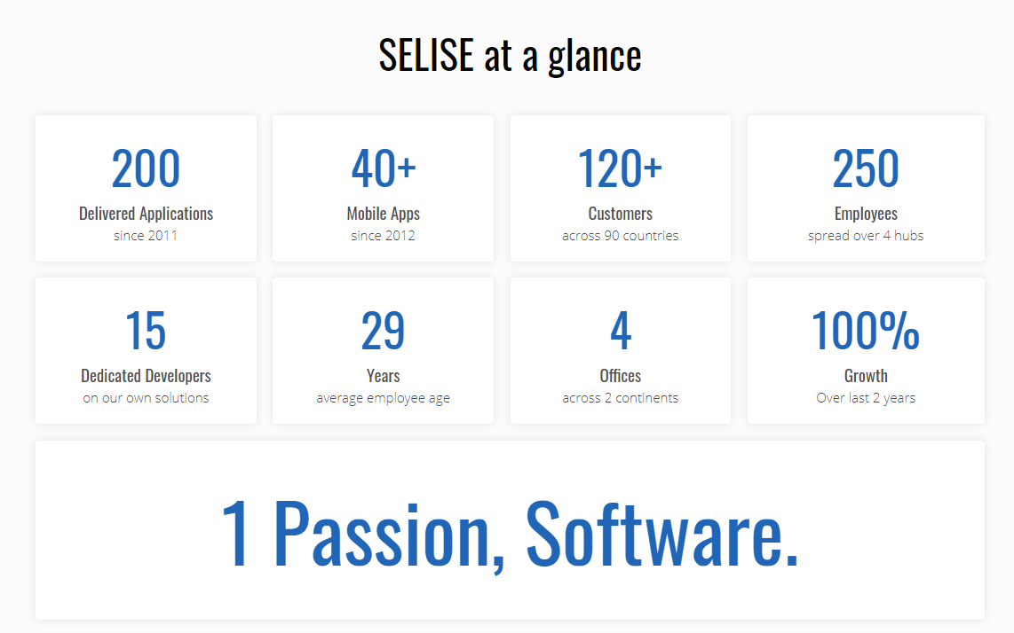

Figure SELISE AT A GLANCE

Business and technology must always work in tandem, and SELISE reinforces all of their digital solutions with a business mindset- from start to finish; from the discovery of a product to when it goes live. The consulting team at SELISE comprises of digital natives who understand how digital organizations are structured, and how they can best interact with their markets.

## MANAGEMENT

SELISE managing board consist of four members namely Kurt D. Weber positioned as Chairman of the company, Felix Amberg as a member of the board , Julian A. Weber as Chief Executive Officer, Shah Topu. Newaj also as a member of the board . SELISE managing board consist of young, energetic and talented people. (Secure Link Services Ltd, 2020)



**Kurt D. Weber**

Chairman of the Board

SELISE rockin’ software (Secure Link Services Ltd.)

President of Porsche Green Club Suisse



**Felix Amberg**

Member of the Board

SELISE rockin’ software (Secure Link Services Ltd.)

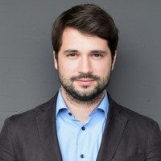

**Julian A. Weber**

Delegate of the Boards of

All SELISE Companies

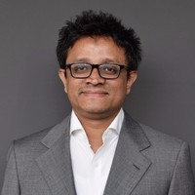

**Shah Topu Newaj**

Member of the Board

Secure Link Services BD Ltd

Figure Governing body of Selise

## VISION AND MISSION

**Meets Reality, Creates Future** to bear this moto in mind SELISE strives to become a global brandfor high-class software product engineering. SELISE’s mission is to provide customers with services which are strongly based on intellectual capacity and with best technology of current world to fulfill all needs of its clients.

### Strategy

The strategy of SELISE is to have genuine understanding of their clients business goals. It is a key building block of its services. SELISE develops digital platform strategies, calculate business cases and come up with generic expansion plans for a number of customers every year.

### Process

With a solid strategy carved out, SELISE cross check the existing business processes against the ambitions. They enhance existing processes and form new ones using business process reengineering techniques taught at the University of St. Gallen.

### System

Once strategy and processes are aligned, a digital platform, a piece of enterprise software or a mobile app can generate business success. SELISE conduct research, build proof of concepts and prototypes to ensure what we intend to build fits this goal.

## WHAT SELISE DO

SELISE manage software projects in what they consult, architect, develop, design and test. Any software development process needs complete integration of customer requirements, development, user interface design and validation. Projects are done with the critical participation of a senior SELISE system architect at the staring phase of planning. A detailed wireframe of the software system is delivered to clients for integration of user requirements and system architecture. After this phase development starts and regular testing continues with development process. Regular client meetings and live demo are performed as part of project management for being up-to-date with clients and management. Following Figure 3 represents their actual integration process of development and requirements.

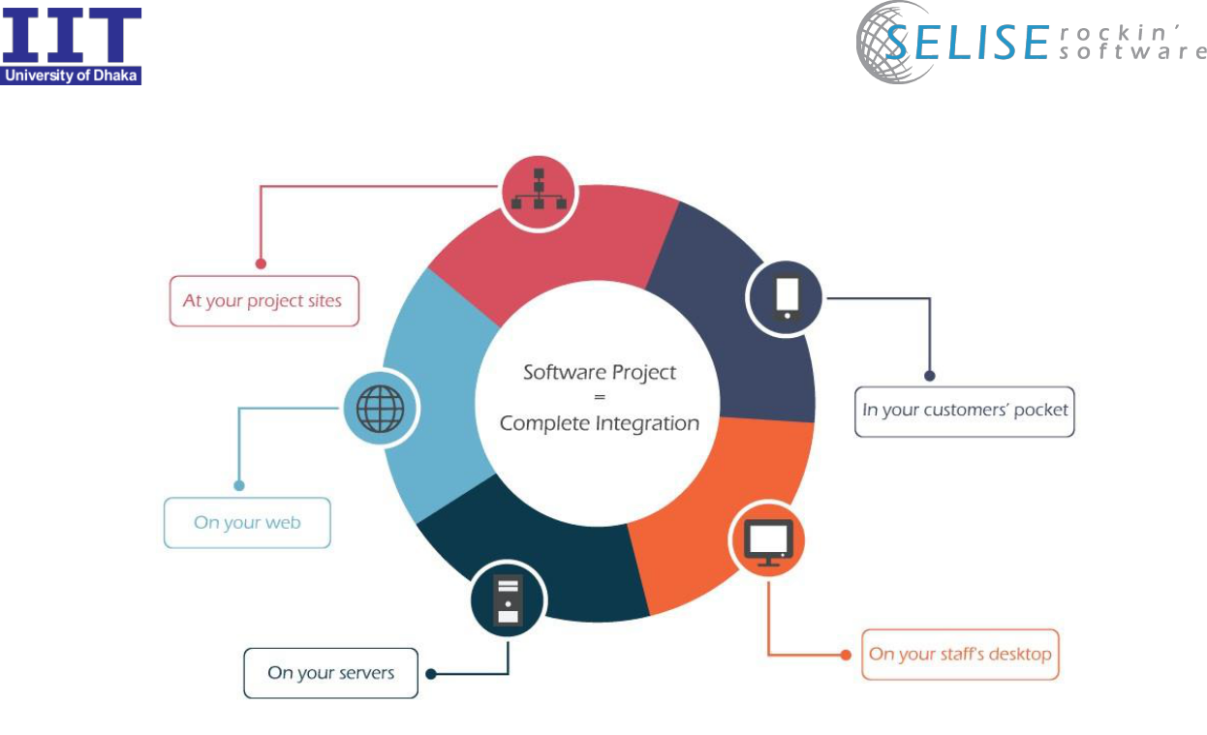

Figure Software Project Integration of SELISE

## MAJOR CLIENTS

SELISE is expert in developing software that requires to be developed from scratch or needs to be rebuilt. Because of their impressive way of developing quality product, SwissLife, ruf, investiere, index capital group and blue code have become their major clients. With the cooperation of highly qualified work force distributed over Dhaka, Zurich Thimphu and Dubai SELISE is working for the clients who are in consulting, e-government, banking and finance.

Customers of the clients are the end customers for whom SELISE focus on in all their work.

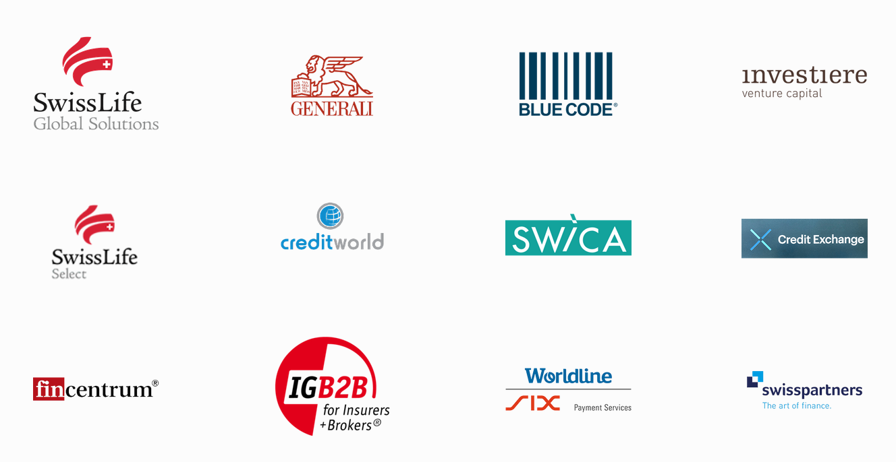

Figure Major Clients of SELISE

## SELISE PARTNERS

To truly accomplish world wide connectivity and world class performance SELISE relies on trusted partners . It helps SELISE to deliver products and communicate with international clients So the developers and customers can also have supports from its partners . Some of its trusted partners are following .



Figure SELISE Partners

## DEVELOPMENT SKILLS AND EXPERIENCE

SELISE has wide experience both in development platforms and business domains. It does not specialize in particular technologies, but it has definitely proficient and experienced with a wide array of tools and systems. Every product is unique and it tries to fit the right team with the right skills for that particular product. SELISE has gained expertise in different types of field. Following are some of them:

* National archive for government
* Garments procurement app
* Content management system
* Parking management app for a start-up
* Referral app for a large financial company
* Advertisement campaign manager for a large financial company
* File system drive for government
* E-commerce
* Banking
* Financing
* Consultancy
* Performance measurement application
* Payment systems

## HUMAN RESOURCE

SELISE has a family of about 250 Rockstars. They are planning to recruit more. Since the beginning, SELISE has grown in number of resources and production every year. SELISE always look forward to hire the best. They have their unique hiring process including Super Talent Program and also emphasize on training and schooling facilities to keep their employees up-to-date with new technologies.

## RECRUITMENT PROCESS

For recruiting experienced professionals, this goes like an initial phone interview and upon getting a green signal here, a face to face interview. After this interview, they decide whether they can hire the candidate or not. SELISE believes in what a person actually is, not just facts on paper. So candidates need to bring examples of work they’ve done, cool stuff that they are passionate about, and things they want to do. Interviews range from pointed questions about work examples to casual conversations about life. For fresher, SELISE has Super Talent Program. This is an accelerated program to take Rockstars to the next level with duration of 3 years with clear indications of the salary package, career growth, increment etc.

## TECHNOLOGIES AND FRAMEWORKS

SELISE is not specialized or stuck within specific technologies. With passage of time they gain expertise in different technologies and frameworks and arrange seminars or schooling programs to share the knowledge with other SELISIAN. Following are some of their used tools:

|  |  |
| --- | --- |
| .NET & Microsort World: | ADO.Net Entity Framework, ASP.NET MVC, |
|  | Microsoft Enterprise Library, Share Point, |
|  | Spring , Entity Framework , Access DB |
|  |  |
| JAVA world: | Spring, Hibernate, JSP |
|  |  |
| Servers etc: | Tomacat, Nginx, IIS |
|  |  |
| Database and NOSQL: | MS SQL Server, MySQL, Mongo DB, Oracle |
|  |  |
| Javascript Universe: | jQuery, jQury UI, Node.js, AngularJS, Angular |
|  | Knockout.js |
|  |  |
| World of Web: | HTML, CSS, DHTML, XML, XHTML, XSLT |
|  |  |
| Mobile Space: | Objective C, jQuery Mobile, Android, HTML5, |
|  |  |
| Framework and Concepts: | Pear framework, Event sourcing pattern |
|  |  |
| Services: | Real time notification, Smart communication, |
|  | Mail sending service |

Table 1 Technology and concepts used by Selise

## OFFICE SCHEDULE

SELISE offers flexible time schedule for employees. Sunday to Thursday is official working days. Though employees are expected to work 9 hours per day (8 hours in Ramadan), a full day time is considered if anyone enters the office before 12 pm and leaves the office after 4 pm by the measuring the time of employee punch card. Employee are not supposed to work in pressure, they can take breaks during their work.

## DRESS CODE

There is no specific dress code in SELISE. Most of the employee comes with formal dress up. But no one is allowed to reach office with unusual dress up. Dress that contains logo of other software firms or competitors is not allowed in office space.

## FINE SYSTEM

SELISE maintain some rules and employees must follow the rules. Breaking official rules there is fine system with different amount. These fine are collected and used for small parties or events for recreation of employees. There a ‘lost and found’ box for keeping lost property of employees. If anyone can give proof of the ownership of the property, then he/she need to pay fine to regain the property. Employees are also fined in case of being late in CTO and scrum meeting.

SELISE follow fine driven development in development of software. There are some rules in development, UX design and employees should follow those rules in case of avoiding the fine. This fine system actually makes the product to be best.

## ORGANIZED STRUCTURE

SELISE practices an organized company structure. All the official works are done through a predefined official process. In case of leave management, the employee needs to fill up a leave application and require the signature of the team lead for approving it. Each employee has 15 holidays in a year other than the government holidays. So employee can use these holidays as per their needs. 7 holidays for intern that is the half of employee leave due to 6th month internship.

## CULTURE

Culture of an organization motivates one person to work on and stay long to that organization. SELISE has a great working environment with a rich culture of fun and professionalism that attracts the best talent. Cultures that I have found in SELISE Software are discussed below:

### People

In SELISE peoples are so generous, friendly and rock stars as its culture of constructive criticism, learning and sharing expands the horizons and keeps employee level headed. Work with amazing personalities and talented people is always inspiring. I have loved to work in such organization.

### Fun and Passion

All the employees are always connected with each other and share a special bond among them. Sometimes it’s about doing research and development, sometimes having errors in code, sometimes discovering new solutions to problems, sometimes planning for events or sometimes it’s just selfie time.

### Sports

Sports are a part of SELISIAN culture. All the time there is a crowd seen around the playground. Everyone competes to get the play board. Yearly playing tournaments are arranged and rewards are given to the winners.

### Working Environment

SELISE has a great working environment at the office space, totally custom designed for a software development company. From color selection to furniture orientation it has been very careful to create an environment that actively enhances the knowledge exchange and collaborative nature of work. All teams are working dedicatedly in their own rooms.

### Annual Trip

SELISIANS are always on the move – let it be the annual company trips and individual business trips throughout the world or fun trips to cool places in Bangladesh. Switzerland, Austria, Germany, UAE, Malaysia, India, Bhutan – everywhere new experiences are enriching and refreshing SELISE minds.

# INTERNSHIP AT SELISE

## OVERVIEW

Internship is an opportunity to familiar with own job field and to get a knowledge how real life industry works are running before ending graduation. It very important to gathering practical knowledge, especially for technological students. It works like a bridge between the software industry and the students. It is a way for both the company and the student to promote each other where student represents their talent and capabilities and industry represents their culture, working environment and technology. As a student of Bachelor of Science of Software Engineering (BSSE) this year I got the opportunity to be an intern at SELISE. I am so delighted to be a part of SELISE in my internship.

Internship provides bigger scope to learn and gather knowledge which ultimately broaden ones vision and ability to dream big to work one of the top industries of software engineering. This internship experience helps me not only to practice my theoretical knowledge and sharing my ideas but also make me conscious of different perspective of software industries of Bangladesh and has given me encourage to work for the best software industries in world.

## IIT AND SELISE

In 2013, a discussion with SELISE CTO Shah Newaj Topu was the initiation of journey in SELISE to take intern from IIT. In 2015 the journey start with two of our senior as intern in SELISE. This year I am selected to take internship in SELISE. Relation between SELISE and IIT not only restricted with this intern opportunity but also SELISE share their knowledge in IIT through seminar or tech talk.

## FACILITIES FOR INTERNS

From the first day, SELISE family welcomed us just like any new employee. We were introduced to the other members of SELISE family by the human resource manager of SELISE. To help interns to do better SELISE has taken step to give us latest generation Asus Vivobook laptops. We are treated as any other employee of SELISE. It never makes us feel that we are the intern here rather than an employee. From the beginning, we are taken care by our supervisor. They spent their valuable time to make us comfortable and adaptable to the new environment and technologies.

* Dedicated workspace like any other employee
* Individual laptop
* Breakfast and lunch spaces as well as snack corner
* Become a member of real-life project team
* Flexible working time and environment
* Leave for academic activities
* Healthy amount of remuneration
* Small sessions on new topic from SELISE Club
* Opportunity to work in real life project

## TRAINING PROGRAMS AND SELISE CLUB

SELISE training program is completely autonomous in its activities . Before the training started I was training under my supervisor . He talk with me about different approaches of solving problems . He guides me if I do mistake or if I don’t know about something . He takes time give detailed information about the topic at hand. I was also given access to C# tutorials so that I can easily grasp the materials . After enrolling in SELISE training program I was given the chance to gain important advice in the use of coding principals and C# features . Our teacher MD. Jalal Uddin would give us proper example C# features and give out assignments . He also took special care so that we would have a good understanding of version control . We are enrolled to attend after office period. We were provided delicious snacks during the classes. The class was mandatory for all interns and new employees . So I had fun attending it with two of my team members .

## ASSIGNMENT OF WORK

In most of the cases, the company treated intern as immature resources. Besides, they are not assigned to real work. However, SELISE not only gave us the opportunity to work in real life projects but also allow us to share our personal opinions and approach to finding out the solution of a problem. If our approach is considered appropriate to them, it is cordially accepted and they implement it into their project. This also gives us inspirations and motivations to keep that practice.

## EVALUATION OF INTERNS

Every learning program should be ended up with the evaluation process. To evaluate our intern period an evaluation form is delivered to SELISE. My Supervisor , Business head and PDM decide how my intern was and evaluate me based on that. The feedback of this evaluation is really essential for me to improve myself and overcome my weakness for my future career.

## CONCEPTS I HAVE LEARNED

In SELISE, I have learned so many new concepts like – Desktop application, DotNet Modules, C# generics and events, Data binding, Scopes, Fluent validation , HTML , CSS , Javascript DOM manupulations , JQuery , Project structure, Microsoft Access DB , Database manipulations , Entity Frame work , Windows forms , Desktop application , SOLID principle examples , Version Control , Git Flow , C# Delegates , Lambda expression , LINQ , Nullable types , Asynchronous Programming with async & await, Extension methods , FlatUI , Dependency Injection etc.

## TUTORIALS AND OTHER RESOURCES

My team leader and team members share important resource such as links, book, and hands on codes to help us overcoming the learning phase. Seniors also help us on how to utilize this resource and how keep the best practices. I am grateful to them in many ways.

## COMMUNICATION AND COLLABORATION

After few days I get familiar with my teammates and colleague’s. I am very fortunate to have such teammates and colleagues very friendly and cooperative. They teach us how to keep up communication among the colleagues using social media and groups. SELISE provides some specific groups to connect its employees such as SELISE Talk in Gmail, SELISE Facebook group, Admin group, Technical Support Group and the Human Recourse Department provide really impressive assistants to us. They help us to learn the company constitutions and rule to be comfortable at SELISE.

## WORKING ENVIRONMENT

In beginning I experienced it a little bit hard to come up with the new technologies in new working environment with a tight deadline. However, there is no fixed time for learning before starting to working in a project. Every time when an unknown problem arises SELISE follows R&D (Research and Development) strategy to find the approximate solution of it.

## CONCLUSION

My internship is now completed after working for full six months from January to June . It was an awesome journey to be a part of SELISE. I just really love and appreciate the facilities provided for us at SELISE. I am thankful to IIT and SELISE for paving the way for me to take my internship at SELISE and completing this internship successfully.

# MY PROJECT INVOLVEMENTS AND CONTRIBUTION

## OVERVIEW

I have joined SELISE on 1st January and on the next day I was introduced to Health Care team. Our PDM Mr. Shumon Sarker introduced me. There I met with my team lead and supervisor Mr. Istiaq Ahmed and other team members . I also joined SELISE Training and learned many things about version control, C# functions, JavaScript etc. I was assigned some assignment from SELISE Training and submitted them through github. In my team I got to learn about dotnet and entity framework. I worked with this team throughout my time as an intern.

In March 18 due to COVID-19 epidemic SELISE created temporary work from home facility . It was permanent a week later . Me along with all my other team members decided to work from home from that day on. I got permission to bring SELISE intern laptop to home because it was needed for the project.

Throughout my internship period I was fully assigned to a wonderful, challenging and long term project named Therapie Plus. The project is still in development stage. The following part of this chapter I describe these phases separately.

## TEAM HEALTH CARE

In Health Care team I was blessed to be have wonderful teammates. They helped me in any and all occasions. I got to have an exciting internship because of them. Our team was handed with three project from the same international company. These projects were a part of each other. I got the chance to work with the development team in Therapie Plus which was the main project. It helped me to integrate and use my theoretical knowledge in practical scenarios.

### Team Members:

Name of my team members –

* Shumon Sarker (PDM)
* Istiaq Ahmed (Team-Lead , Software Architect)
* Shamsad Zaman (Software Engineer)
* Tauheedul Maruf (Software Engineer)
* G.M Jahangir Abbus (Software Engineer)
* Waliul Hasan (Software Engineer)
* Koushik Kumar Ghosh (Software Engineer)
* Saadman Malik (Software Engineer)
* Asif Muhammad Arshadullah (Software Engineer)

I worked with them for six months and learned a lot from them. They taught me many technical skills as well as important soft skills that are needed when working in a company.

### Tools and Technologies

The following tools and technologies have been used for the development of the project:

* Microsoft .Net framework
* MySQL
* Microsoft Access Database
* Visual Studio 2019
* Entity framework
* Visual Basic 6.0
* Crystal Report
* Microsoft Access 2010
* VB Migration Partner
* Fluent Validation
* Source Tree
* Jira

### Working Period

I have been assigned in Health Care team in January 2nd and worked there until the end of my internship. I have worked successfully in my team.

## My Contribution

I have contributed to this project mostly in developing. As we have need to test task before it moves to QA, I have implemented some features, improve existing one and mostly fixing bugs. In the last part of my internship as the project was almost finished developing I was also part of testing and QA. As this is a copyright project with sensitive information I have discussed with my PDM in sharing some screens. After his screening I am left with only some screen shots. The white or blacked out spaces are done by my PDM. In below I have discussed shortly some of my works with the selected screenshots.

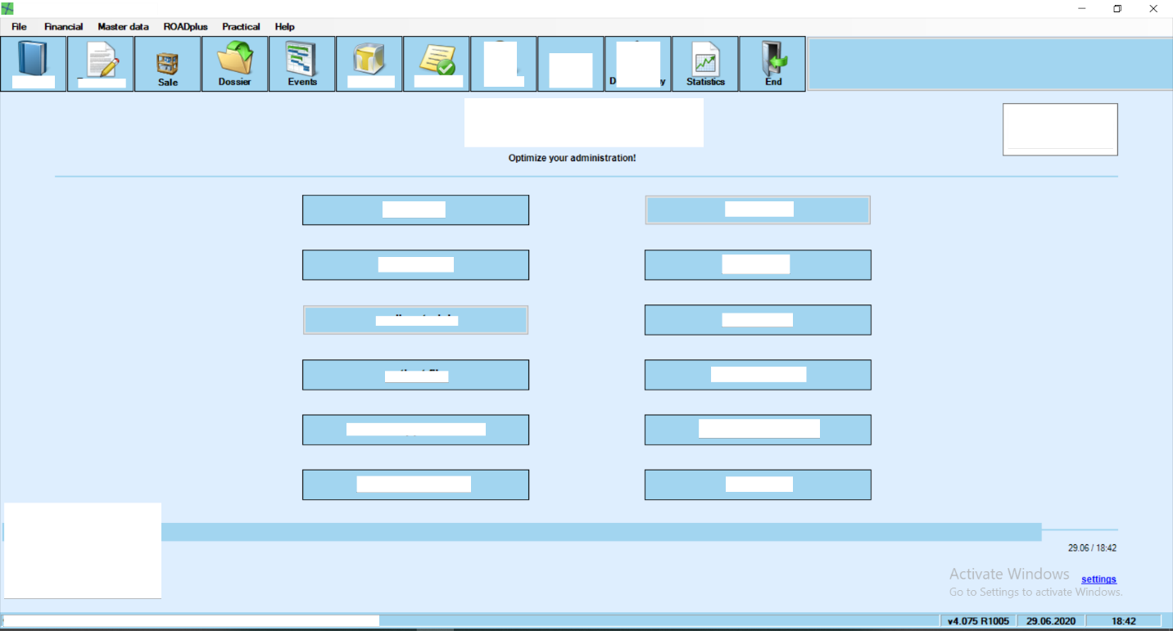

Figure Therapie Plus Home Screen

This is the main menu of Therapie Plus project. This is a desktop application that is developed with dot net technology. As our team was trying to deliver a difficult deadline; I had the chance to work back and forth with many of the menus in this project. In particular I have fully done the help menu in project and done partial work in master data, financial and practical menu. In doing so I got great experience with data handling, data manipulation with the help of entity framework and LINQ and effective coding with standard coding principals. Here I learned that just finishing the code is not all, readability and maintaining coding principals is also very important. My team lead and other team members were very patient with me even if I created some mistake. They taught me important lessons in coding. Now , I will present some of the screens that I have worked on in Therapie Plus project—

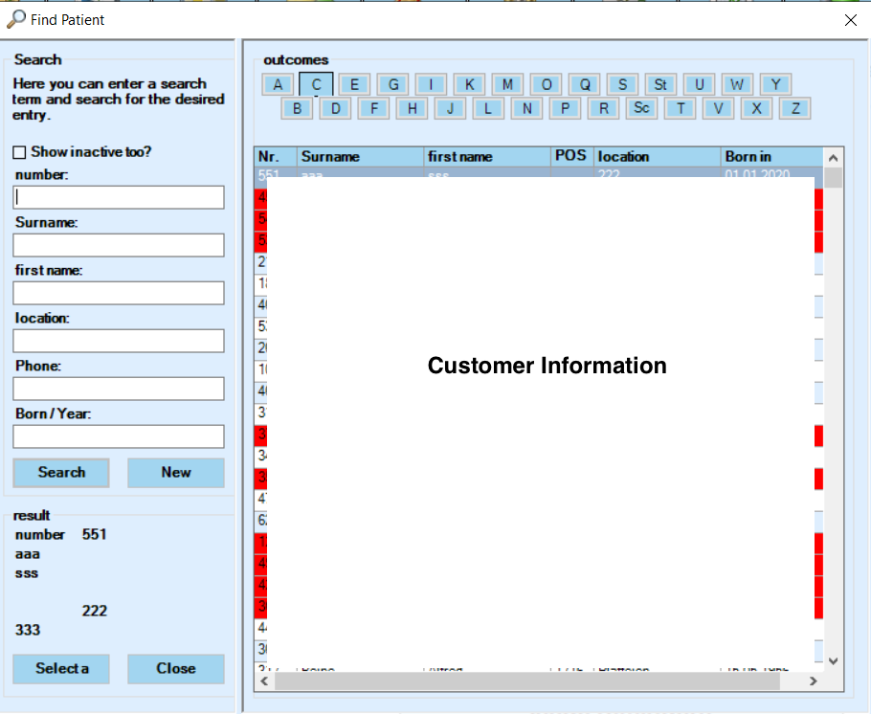

Figure Search Screen

This is the main search screen in the project. I have done phone and Born/Year search options as well as all the testing and Q/A for this form.

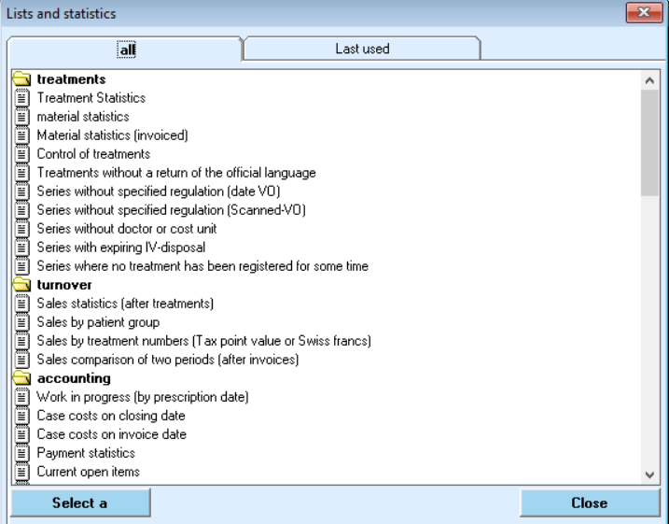

Figure List And Statistics Form

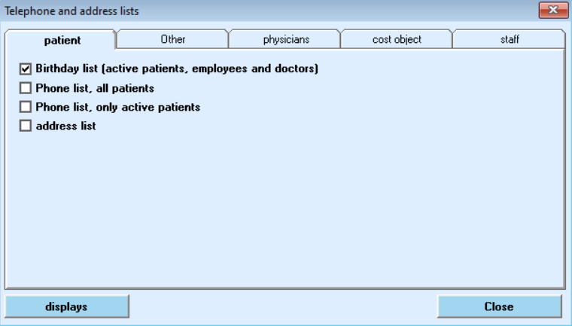

Figure Addresses Lists

Both of these forms use crystal reporting to print relevant lists. They combined print almost 120 lists. Each of the lists having 3 different language components. As this was a lengthy and big work I have worked some time finishing these with a few of my team members. I have also done the testing and Q/A part of these reports. After this are some of the forms where I had done all the work.

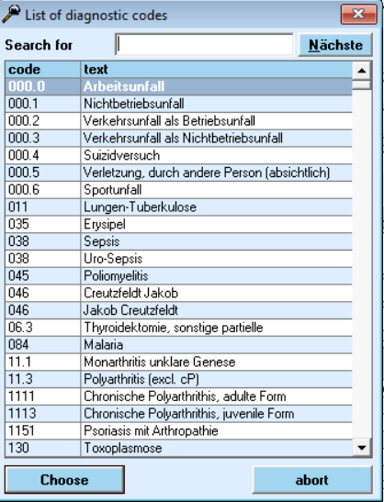

Figure Diagnostic Code List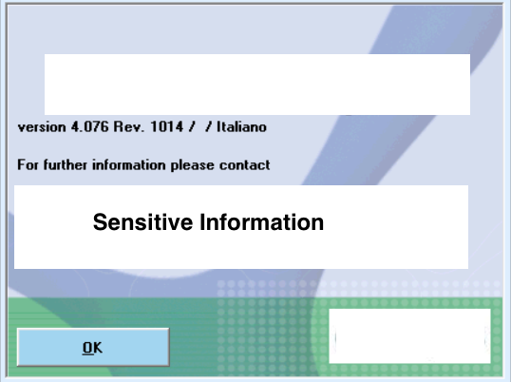

Figure Info Form

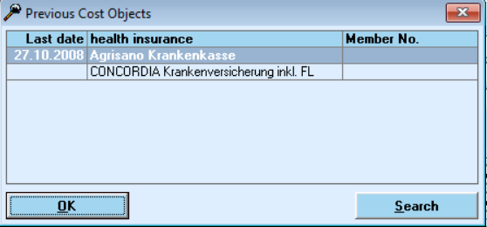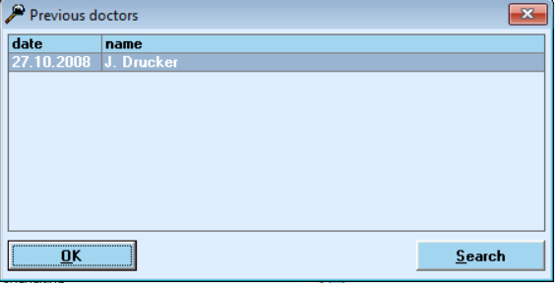

Figure DOCTOR SEARCH LIST

Figure Guarantor Search List

This is only some of the forms that I have worked on. I have also helped creating or implementing many forms. But as all of them contains highly sensitive information I cannot use them. These are the only screens left after the screening of my PDM. Also as I mentioned before I have also converted almost 200 VB6 forms to windows forms that helped accelerate progress. All in all I was lucky to be involved with many sectors of software development.

## Challenges

As my project is an international project in SELISE it is given the utmost priority. We have followed agile development methodology. Every two to four weeks there is a release of sprint. So, I have faced many challenges to perform my assigned tasks.

* Working as a backend developer, debugging dot net code and analyzing bugs were difficult.
* To integrate to the whole project with entity framework and Microsoft access data base was difficult.
* Evolving requirement engineering, implement new features, improvement and bug fixing of existing features with time constraint and deadline was so much difficult.
* Testing the code with various angles and parameters was challenging and difficult.
* Working with new technologies and shifting focus from development to testing was challenging.

## WORK FROM HOME (WFH)

From March 18, 2020 I had to begin work from home because of the global epidemic caused by COVID 19. It was an unlucky spell to spend more than half of the internship period working from home. However, with the support I got from SELISE and my team mates we are able to work effectively and productively. SELISE had enabled me to bring my work laptop to home. And also created remote desktop environment for all of my other team mates.

### Work time in WFH

In this remaining time in work from home my workload and work pressure increased because of the approaching deadline. All of team Health Care work hard above the required time of 9 hours per day. Some of my team mates work more than 10 hours. There are also some flexibility such that one can toll their missing work hours in weekends or holidays.

### Gift Pack

During the pandemic to help employees in difficult times SELISE sent a big gift pack to all the employees that were currently in Dhaka. They have directly delivered it to the home of the employees. I have also received such a gift pack. It contained delicacies as well as much needed hand sanitizers, masks and gloves.

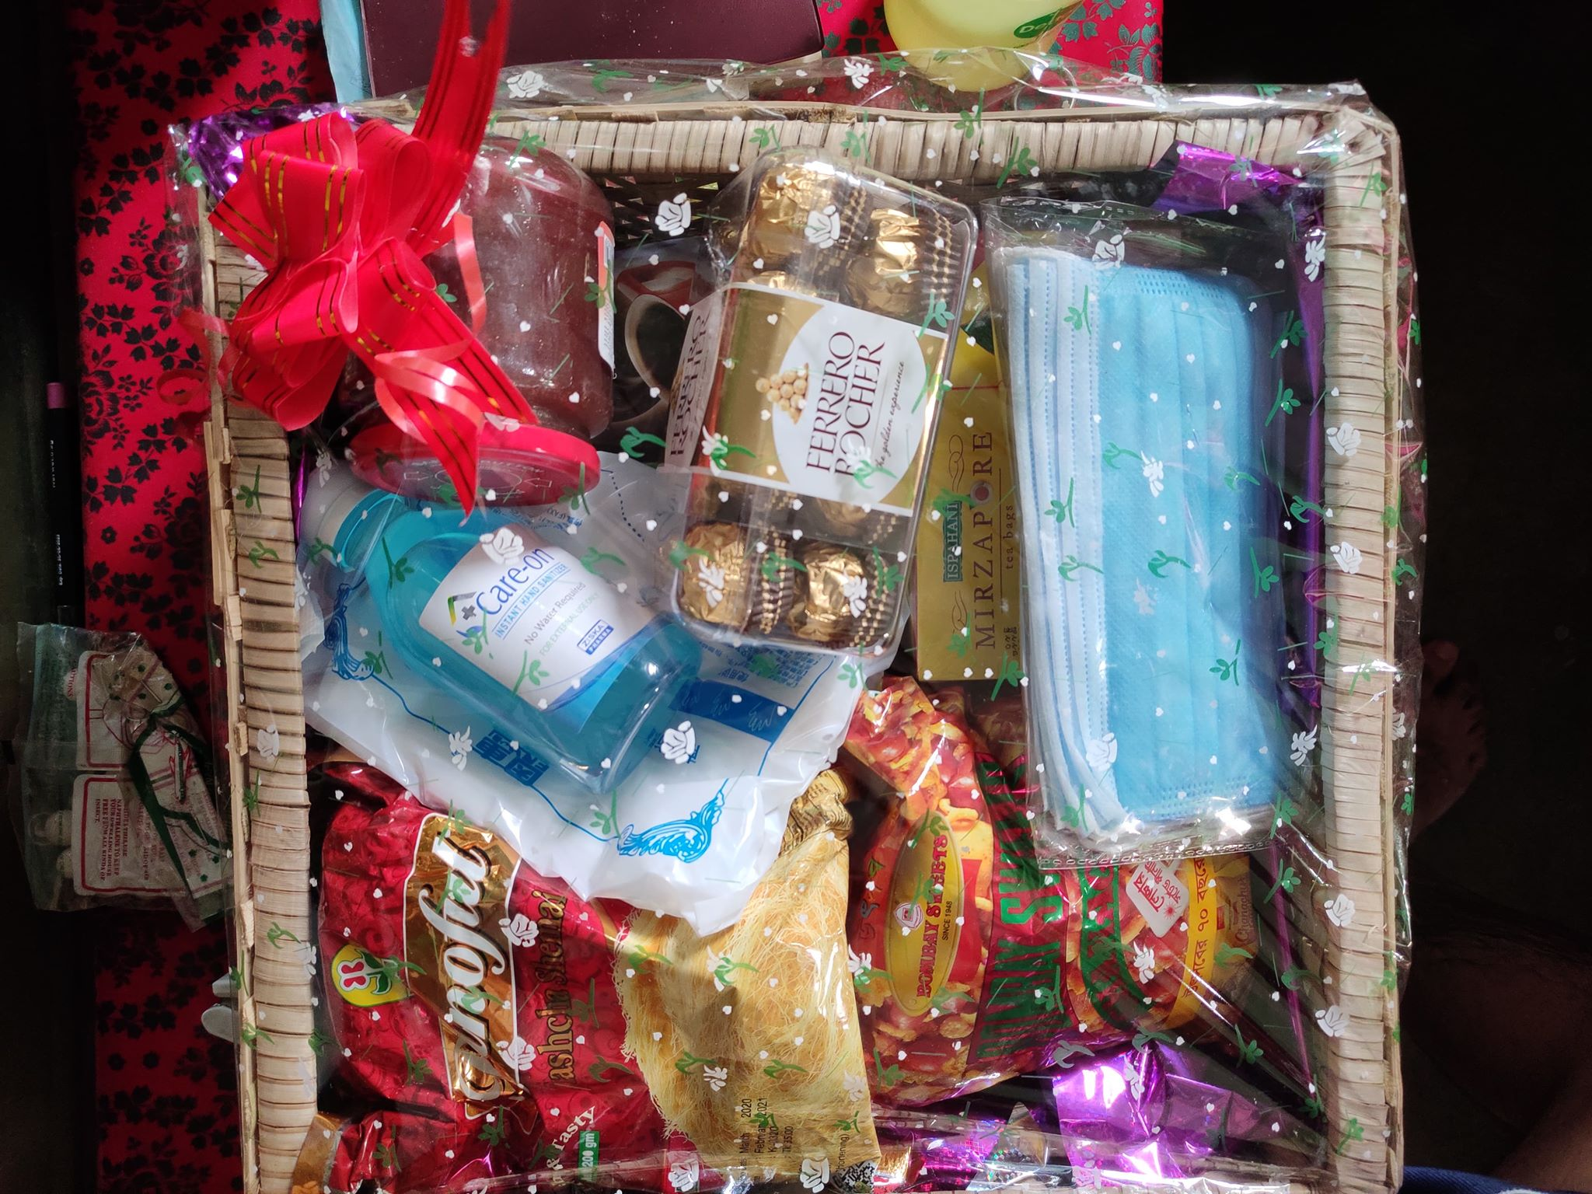

Figure Gift Pack

### Communication

To give the freedom of work and to enhance communication and productivity we had scheduled various scrum meeting time with the help of google meet. In accordance with agile methodology, we have 2 scrum meetings each day. One at 10:00 AM morning scrum and later at 7:00 PM evening scrum. All the team members share their status in these scrums. They can share their problems or blockers or dependency to other team members in the scrum. It is a responsibility and opportunity to participate in scrum. If anybody is late to join, he is fined **50** taka. Other than that, if any team member has any inquiry, they can post in hangout group chat or call other team member in hangout. One has to be active in hangout in all time during the office hours so that he does not miss any important update or questions from other team members.

### Collaborations

If any team member need guidance from team lead or senior members with questions or review codes they can share their screens with google hangout video calls. If they need special solutions involving complex instructions, they can use Team Viewer to remotely control the pc. For code reviews after finishing a task card in JIRA one has to put the task in review column in JIRA board. Team lead or other senior members will check this task and depending on the result put the task card back to working or done column. This way even with WFH our team is able to give 100% productive output under pressure.

# TECHNOLOGICAL GROWTH

## OVERVIEW

As a global software company SELISE works in different platforms on client and product demands. I am working in Health Care team where as I mentioned before I am working in dotnet framework. Since I am considered to be a backend developer, so I need to have major concern in the clients platform. I have learned and used a lot of new tools and technologies. From my point of view, it is the best time to get familiar with different technologies as it helps me to develop my confidence and assist me in my future career.

## TOOLS AND IDE

Choosing appropriate and optimized tool for implementing different problems is an important decision. Programming tools make development easier. Following are the list of tools I used at SELISE for my daily works:

### Azure DevOps

Azure DevOps Server is a Microsoft product that provides version control, reporting, requirements management, project management, automated builds, testing and release management capabilities. It covers the entire application lifecycle, and enables DevOps capabilities. As our whole product is hosted on azure we need to frequently use it. It also works as a bridge to connect client side developers with our developers.

### Visual Studio 2019

Microsoft Visual Studio is an integrated development environment (IDE) from Microsoft. It is used to develop computer programs, as well as websites, web apps, web services and mobile apps. Visual Studio uses Microsoft software development platforms such as Windows API, Windows Forms, Windows Presentation Foundation, Windows Store and Microsoft Silverlight. It can produce both native code and managed code. As a backend developer we needed to constantly use it to develop code. It also provides features with entity framework, crystal report and fluent validation which is a must for our project. I have loved to work with this IDE.

### Crystal Report

Crystal Reports is a business intelligence application, marketed to small and medium businesses by SAP SE. The file extension for Crystal Reports' proprietary file format is .rpt. The design file can be saved without data, or with data for later viewing or sharing. Introduced with the release of Crystal Reports 2011 (version 14.0), the read-only .rptr file extension option allows for viewing, but cannot be modified once exported. Several other applications, including Microsoft Visual Studio versions 2003 through 2008, and Borland Delphi, at one time bundled an OEM version of Crystal Reports as a general purpose reporting tool.

## LANGUAGES AND FRAMEWORKS

### C#

C# is a computer programming language. It is developed by Microsoft. It was created to use all capacities of .NET platform. The first version was released in 2001. The most recent version is C# 8.0, which was released in September 2019. C# is a modern language. C#'s development team is led by Anders Hejlsberg, the creator of Delphi. By design, C# is the programming language that most directly reflects the underlying Common Language Infrastructure (CLI). Most of its intrinsic types correspond to value-types implemented by the CLI framework. However, the language specification does not state the code generation requirements of the compiler: that is, it does not state that a C# compiler must target a Common Language Runtime, or generate Common Intermediate Language (CIL), or generate any other specific format.

### .Net Core

.NET Core is a free and open-source, managed computer software framework for Windows, Linux, and macOS operating systems. It is a cross-platform successor to .NET Framework. The project is primarily developed by Microsoft and released under the MIT License. .NET Core supports four cross-platform scenarios: ASP.NET Core web apps; command-line apps; libraries; and Universal Windows Platform apps. Prior to .NET Core 3.0, it did not implement Windows Forms or Windows Presentation Foundation (WPF), which render the standard GUI for desktop software on Windows. Now, however, .NET Core 3 supports desktop technologies Windows Forms, WPF, and Universal Windows Platform (UWP).

### Entity Framework

The Entity Framework is a set of technologies in ADO.NET that support the development of data-oriented software applications. Architects and developers of data-oriented applications have typically struggled with the need to achieve two very different objectives. They must model the entities, relationships, and logic of the business problems they are solving, and they must also work with the data engines used to store and retrieve the data. The data may span multiple storage systems, each with its own protocols; even applications that work with a single storage system must balance the requirements of the storage system against the requirements of writing efficient and maintainable application code.

The Entity Framework enables developers to work with data in the form of domain-specific objects and properties, such as customers and customer addresses, without having to concern themselves with the underlying database tables and columns where this data is stored. With the Entity Framework, developers can work at a higher level of abstraction when they deal with data, and can create and maintain data-oriented applications with less code than in traditional applications. In our project we had to model and map a lot of custom objects and entities. Using this has helped us to communicate with the database on a deeper and easier level.

## SOURCE CONTROL AND OTHERS TOOLS

### Jira

Jira is a proprietary issue tracking product, developed by Atlassian. It provides bug tracking, issue tracking, and project management functions. In Jira we can add different boards, filters to manage our agile development process. Our whole project is handled by using Jira board. One can see his assigned tasks and the sprint activities in the agile current sprint dashboard. Maintain Jira to develop a project provides whole team, clients a well-managed view of how evolving development process works. With its enormous features it eases development and helps all developers, project manager, and quality assurance coherent with right track.

### Sourcetree

SourceTree is a powerful Git management tool. Our full project is handled in Git using this tool. All the members work concurrently on their PC and all their submissions are merged by SourceTree. Branching, pushing or pulling all Git essential activity can easily managed with this tool. I have learned working with version control system with Git in SELISE.

### TortoiseGit

TortoiseGit is a Git revision control client, implemented as a Windows shell extension and based on TortoiseSVN. It is free software released under the GNU General Public License.In Windows Explorer, besides showing context menu items for Git commands, TortoiseGit provides icon overlays that indicate the status of Git working trees and files.It also comes with the TortoiseGitMerge utility to visually compare two files and resolve conflicts..

# CONCLUSION

To complete my academic learning and before move towards the next level of my career the internship program was the most important part in my BSSE program. Journey to be a professional software engineer it never be so perfect without working in a renowned software company like SELISE. The internship program made me accustomed to the professional company culture and the technologies they mostly deal with. Throughout my internship it has helped me to develop professionalism, patience, good judgment and made me so strong to face new problems, challenges which has helped me to develop better analytical skills also. The projects in which I worked inspired me to be confident, responsible and helped me with all means to build a research mind, motivate to works, enjoying my works.

The internship program has been a great helping the sense that it improved my team work capabilities. At the companies it is important to function as a unit and respect the team mate’s ideas and suggestions. Team discussions like brain storming sessions helped me identify and solve numerous problem issues which would have been impossible to solve otherwise.

I would like to convey my thanks to Institute of Information Technology for providing me an opportunity to gain idea of the competitive environment in the professional field. It has certainly lifted my software development skills in terms of design and coding. Now I look forward to facing the upcoming challenges of the world.

# REFERENCES

1. jawiddis. "Visual Studio 2019 Release Notes". docs.microsoft.com. Retrieved 30 June 2020.
2. TerryGLee. "Visual Studio build numbers and release dates". docs.microsoft.com. Retrieved 30 June 2020.
3. Krill, Paul. "Microsoft open-sources Entity Framework". InfoWorld. Retrieved 7 July 2020.
4. <https://docs.microsoft.com/en-us/dotnet/framework/data/adonet/ef/overview>, Retrieved 7 July 2020.
5. "Entity Framework - Home". Retrieved 7 July 2020.
6. [https://devblogs.microsoft.com/dotnet/welcome-to-c-9-0](https://devblogs.microsoft.com/dotnet/welcome-to-c-9-0/), Retrieved 7 July 2020.
7. "Crystal Reports family of offerings. Features by edition comparison chart" (PDF). SAP. 2019
8. <https://www.sap.com/index.html> , Retrieved 7 July 2020.
9. https://github.com/dotnet/core/blob/master/release-notes/3.1/3.1.5/3.1.5.md, Retrieved 7 July 2020.